Quality Counts Test Instructions:
If you have already taken and passed the test you do NOT need to retake the test. Please find your name on the list and get your ID number to put on your entry cards.

http://agrilife.org/qualitycounts/verification/
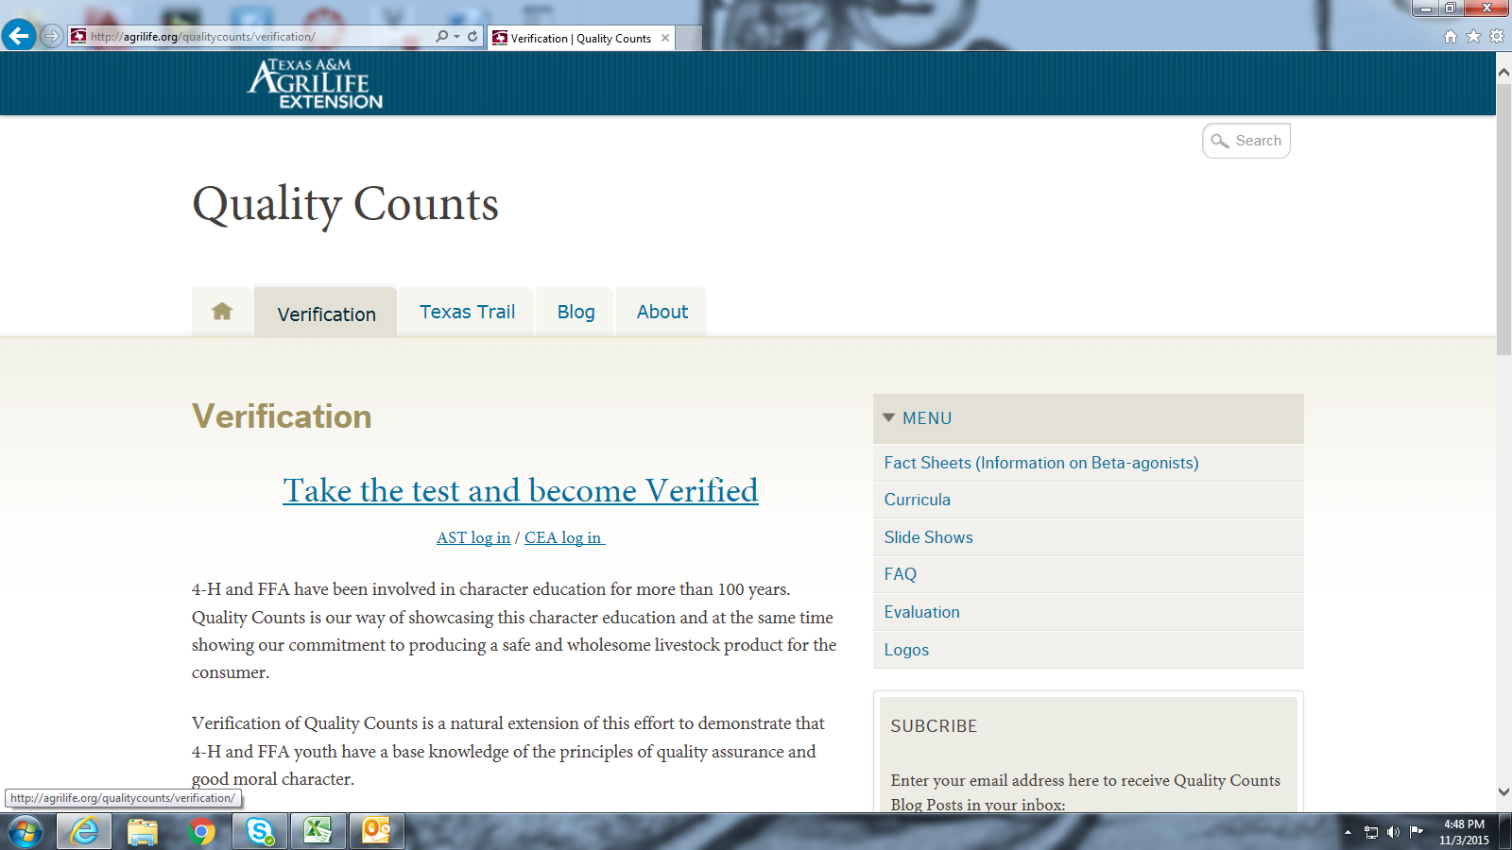

Click on : Take The Test and become verified”
Then once on the screen below click in the middle on the “FFA” button
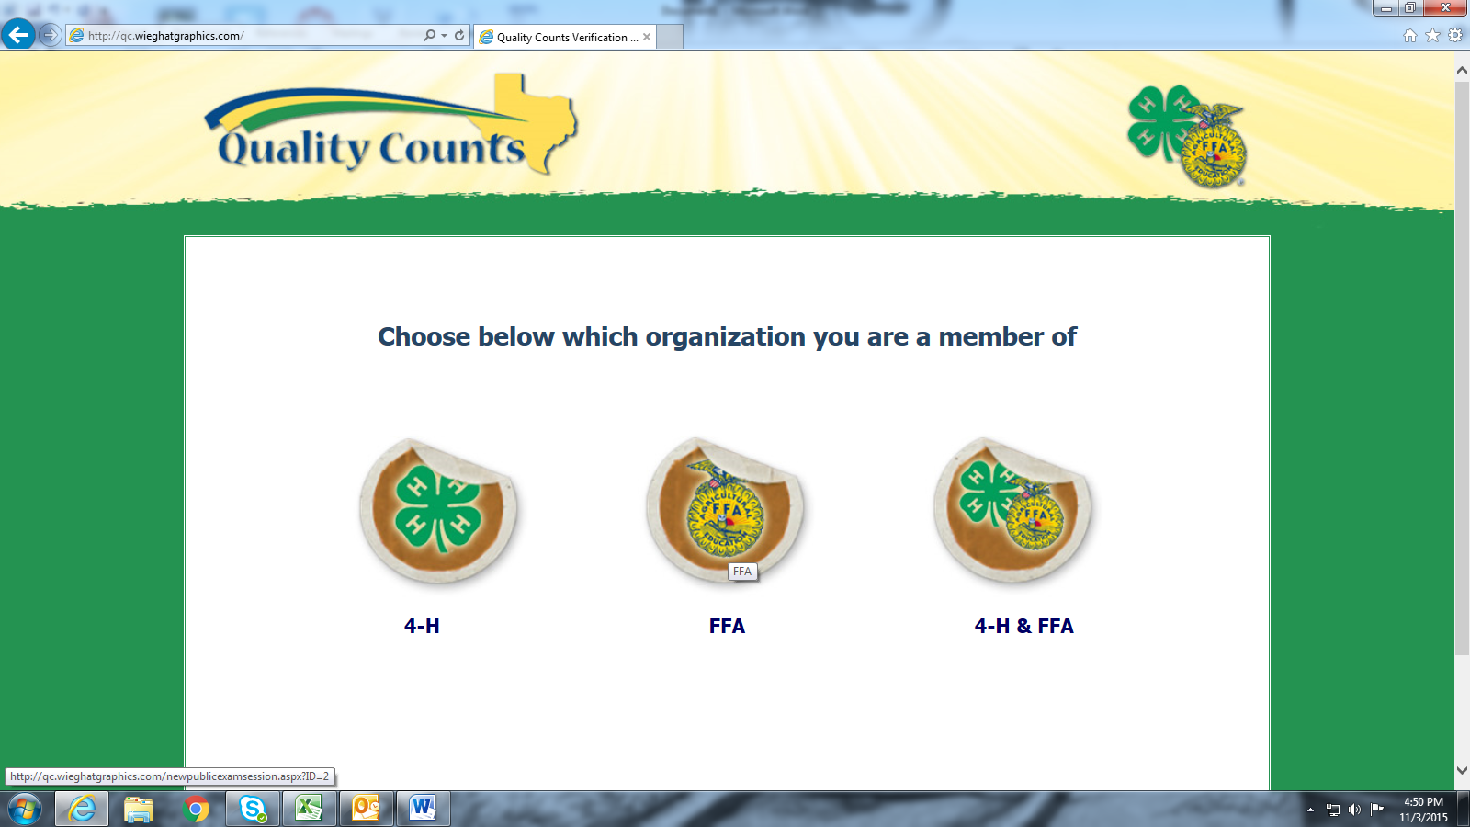
Once you are done with test and pass you will be given a number, this is the number that I will use to enter you for the shows.

